**Certification Project**

Home Automation is one of the fastest growing field with large number of devices currently connected to the internet. Alexa is a voice service which comes hand to hand with automation.

Create Amazon Developers Account

Steps

1. Create a product under the Alexa option

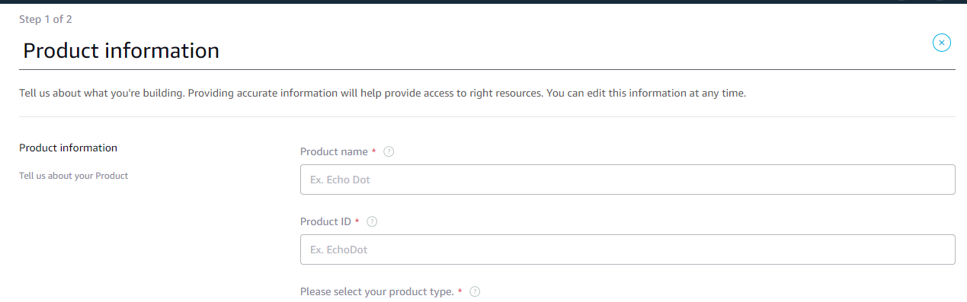

1. This will how the list of devices be listed in the amazon portal

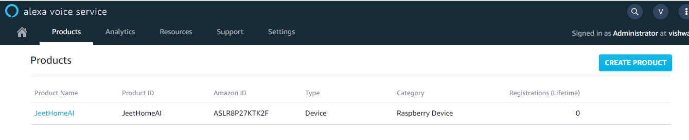

1. Download the file at the end of the registration of product

Paste the config.json file in the raspbian home directory

/home/pi/

1. Run the following commands to install the SDK and configuration scripts

sudo wget <https://raw.githubusercontent.com/alexa-avs-device-sdk/master/tools/Install/setup.sh> \

sudo wget [https://raw.githubusercontent.com/alexa-avs-device-sdk/master/tools/Install/genConfig.sh \](https://raw.githubusercontent.com/alexa-avs-device-sdk/master/tools/Install/genConfig.sh%20\)

sudo wget [https://raw.githubusercontent.com/alexa-avs-device-sdk/master/tools/Install/pi.sh \](https://raw.githubusercontent.com/alexa-avs-device-sdk/master/tools/Install/pi.sh%20\)

1. Run the following commands to accept the licensing

Press the “AGREE” to start the configuration

Type “RETURN” to view the license

After completing a prompt appears type “yes”

1. Run the sample app which is present in the module

$ cd /home/pi/

$ sudo bash startsample.sh

This sample will generate an ***Authentication key*** use this code to register it with the amazon service.

1. To register the device use the authentication code

Visit <https://amazon.com/us/code> and paste your authorized code. This will now register your device.

1. Now your Alexa or amazon voice service is ready to be used
2. Plug your microphone/mic and speakers in the raspberry pi USB hub so that the Alexa is able to take speech as an input and gives us the voice feedback
3. Run the command to start the Alexa

$ sudo bash /home/pi/startsample.sh

1. To keep this code running edit the ***.bash*** file

Just add the following line at the bottom of the file

sudo bash /home/pi/startsample.sh

This will start the script each time the raspberry pi reboots.

1. Since we are using the raspberry pi as Alexa we will be using pubnub and IFTTT service to easy access to our lights scripts.
2. Visit the <https://pubnub.com/> and sign in with your credential. Pubnub is a free open source service for developer. It has IoT API’s to control devices and many more other features.
3. Generate and copy the ***Product and Subscribe Key*** that will be used in the lights python script.
4. To install pubnub run the command on terminal

$ sudo pip install pubnub==3.9.0

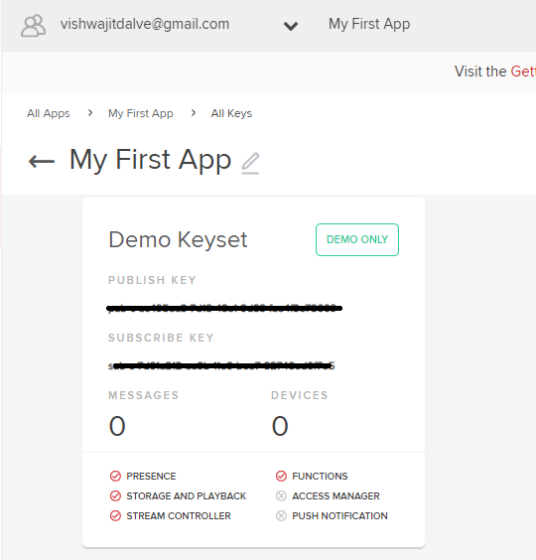

1. Now create an IFTTT service which will trigger certain action if certain action happens. In our case this web service will take the speech from Alexa and trigger a trigger. Create or login to your account.
2. Select create in the profile option and press + to create a new applet.
3. Search for *Amazon Alexa*
4. Choose a trigger as *say a specific phrase – “****turn on the lights****”*
5. Press + to add action
6. Search for *webhooks* this provide REST web request to connect to the pubnub using the subscribe key.
7. Select *make a web request*

In the url section add the following url

[**http://pubsub.pubnub.com//publish/pub_key/sub_key/0/alexaTrigger/0/{"requester":"Alexa","trigger":"light","status":1}**](http://pubsub.pubnub.com/publish/pub_key/sub_key/0/alexaTrigger/0/%7b%22requester%22:%22Alexa%22,%22trigger%22:%22light%22,%22status%22:1%7d)

**Replace the *pub_key* and *sub_key* with your publish and subscribe key.**

1. **Create action button to create the action**
2. At last click the ***finish*** button to deploy it
3. Repeat the same steps to create the action to off the lights, just change the url to
4. [**http://pubsub.pubnub.com//publish/pub_key/sub_key/0/alexaTrigger/0/{"requester":"Alexa","trigger":"light","status":0}**](http://pubsub.pubnub.com/publish/pub_key/sub_key/0/alexaTrigger/0/%7b%22requester%22:%22Alexa%22,%22trigger%22:%22light%22,%22status%22:1%7d)
5. **Now let’s start writing the code for our lights.py file**

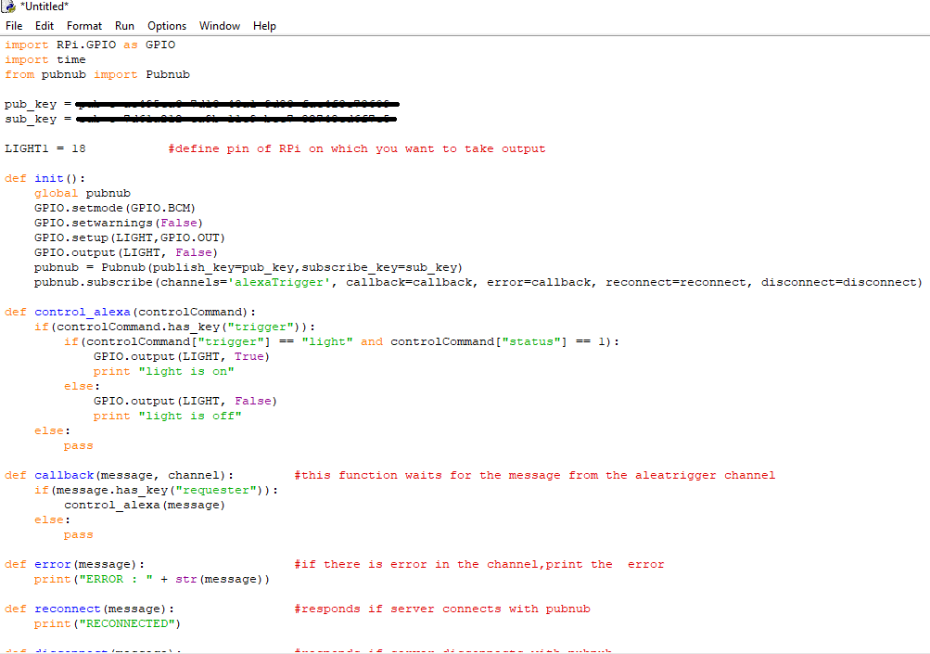

1. Run this python file

$ python lights.py

1. Set this file on the ***.bash*** file so that even this file can run every time the raspberry pi reboots.